**Assignment # 2**

**Instructions For Q1(6 marks)**

1. **Watch video and design exact layout and javascript funcationality.**
2. **For layout designing (2 marks).**
3. **For javascript moving forward and backward feature (4 marks).**

**Q1 Assignment Video Link:**

https://watch.screencastify.com/v/AHRRsDdRL1WYrHNb7mzJ

**Instructions For Q2(4 Marks)**

1. **Design two regix expressions for the two input fields (Password and Phone).**
2. **There should be a form that checks the two input according to the required conditions , and display alert message upon form submission.**

**Assignment 2 Layout**

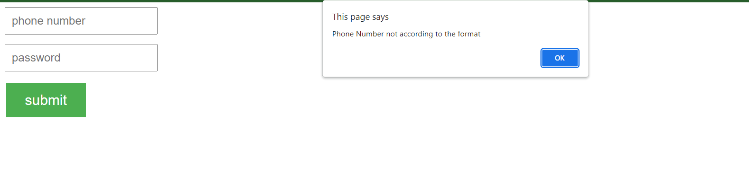

1. **Valid phone numbers are**

**+92123-123-3333,** **+921231233333,** **+92123 123 3333**

1. **Invalid Phone Numbers example:**

**+9212312333,** **12312333,**

1. **Valid Password conditions**

* The password must contain a single Numeric digit from 1 to 9, one lower case ,one upper case and one special character.
* Password must ends with “ucp”.
* Password range should be between 11-16.  
    
  Valid example : 1234567A@aucp  
    
  Invalid Example: 1234567@auc